# Wikipedia

## Definition

**# Source**: **Windows ScreenShots From Site -> https://www.wikipedia.org/ at [8/27/2025]**

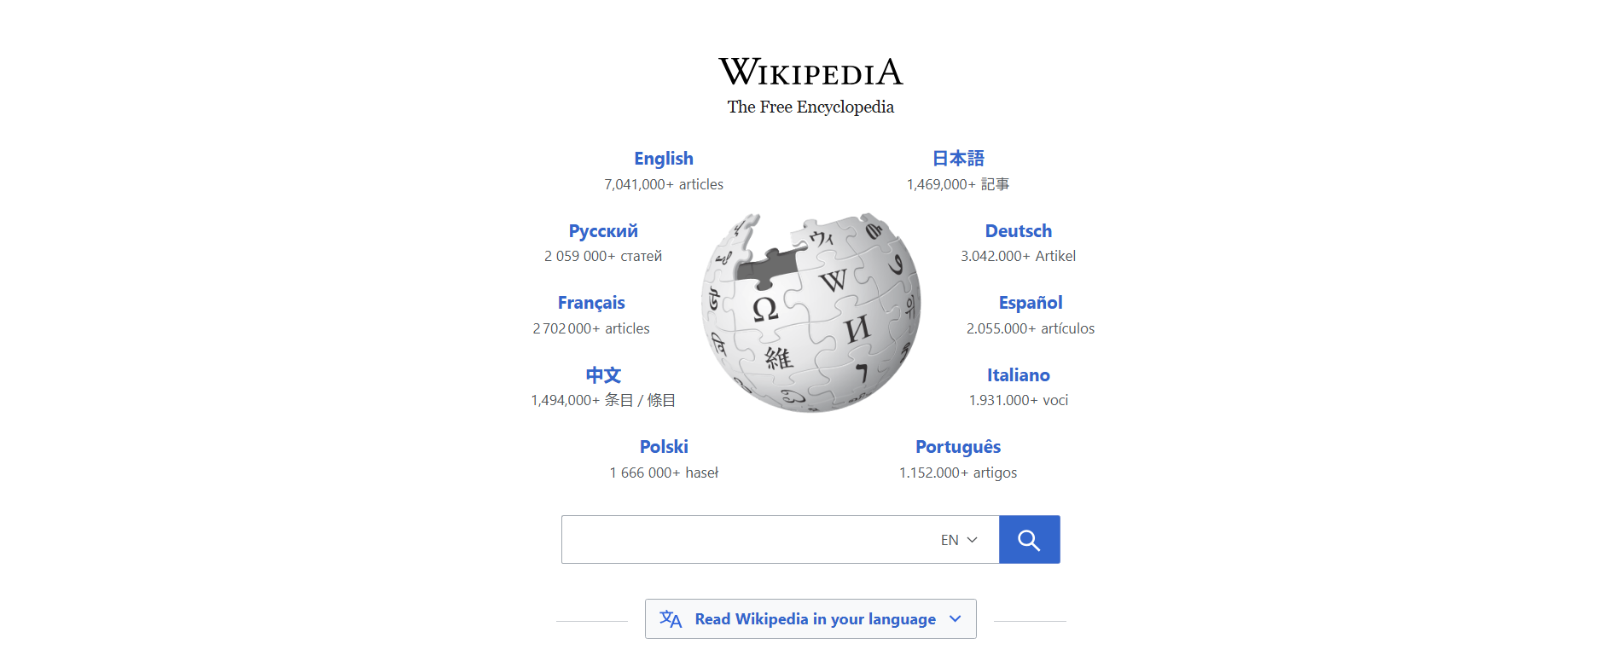

**# Source**: **Chatgpt (GPT-5-Standard) at [8/27/2025]**

**Wikipedia** is a free, web-based **encyclopedia** that allows collaborative editing of its articles by volunteers around the world. It is one of the largest and most widely used sources of general information on the internet.

## Key Highlights

**# Source**: **Chatgpt (GPT-5-Standard) at [8/27/2025]**

* Launched on **January 15, 2001** by Jimmy Wales and Larry Sanger.
* Contains **millions of articles** in multiple languages.
* Uses a **wiki model**, meaning anyone can edit or contribute content.
* Content covers **almost every topic imaginable**, including science, history, technology, culture, and more.
* Operates under a **free license (Creative Commons Attribution-ShareAlike)**.

## Summary Table

**# Source**: **Chatgpt (GPT-5-Standard) at [8/27/2025]**

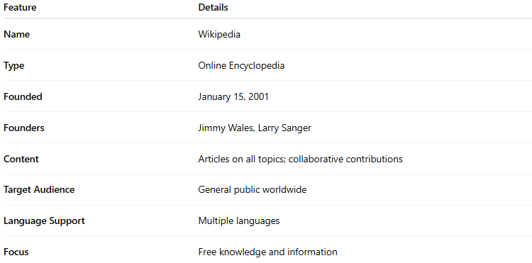

| **Feature** | **Details** |
| --- | --- |
| **Name** | Wikipedia |
| **Type** | Online Encyclopedia |
| **Founded** | January 15, 2001 |
| **Founders** | Jimmy Wales, Larry Sanger |
| **Content** | Articles on all topics; collaborative contributions |
| **Target Audience** | General public worldwide |
| **Language Support** | Multiple languages |
| **Focus** | Free knowledge and information |